**Instruction for Image Analysis Tool v1.0 (beta)**

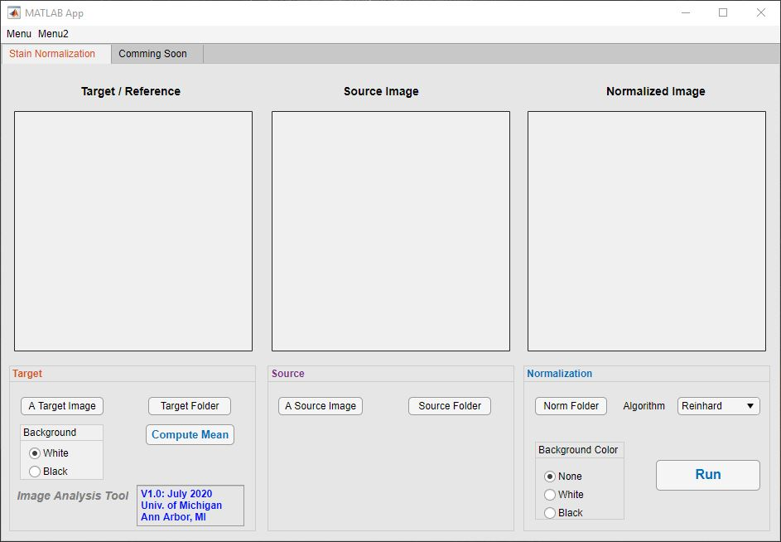

Currently, Only the stain normalization with the Reinhard algorithm is available in this tool.

**Step 1A**: click “A Target Image” on Target panel to load a target image as a reference image or “Target Folder” for all images to compute a reference value for the normalization. [see the status window next Image Analysis Tool to check the status]

Step 1B: if you want to compute a target value from the source data, click “Target Folder” to select data folder. Then select Background color. Then, click “Compute Mean”: it will generate a mask/masks and compute a reference value.

**Step 2:** If a target image has black background, change background color of the image to Black. And repeat Step 1A again. If a target image has the same background color with Background selection, you can skip this Step 2.

**Step 3:** click “A Source Image” to load a source image or “Source Folder” for multiple images.

**Step 4:** click “Norm Folder” to select a save folder or create a save folder if it is not created yet.

**Step 5:** choose background color for the output images (None, White, or Black)

**Step 6:** click “Run” to normalize and save images to the save folder.

This app automatically generates a mask/masks and exclude background for the computation.

The reference image and masks will be automatically saved to “xxx_norm_save” folder for Step 1B.

Depending on the image size, it may take a couple of minutes for each image. [you can check the status in the window next Image Analysis Tool]